**VIDEO: PLO > Low Stakes > Hot and Cold Equity**

**Goal of the video:**

* Define a process for identifying profitable 4-betting ranges against different categories of villains
* Use coarse range and villain categories to construct a “heat map” of [i] profitable, [ii] marginal and [iii] unprofitable 4-bet hands
* Narrow down a problem that is tough to quantify b/c of the number of starting hand combinations.

**Step 1: Define the hand categories that we want to test**

* Eliminate trash & eliminate known good hands (AAxx) from the analysis
* Focus on
  + Double-suited hands
  + Ace-high broadway hands
  + Strong high-card hands
  + Big pairs
  + Unpaired rundowns
  + Double middle-pairs
* Also test some of the above categories in the single-suited / rainbow varieties

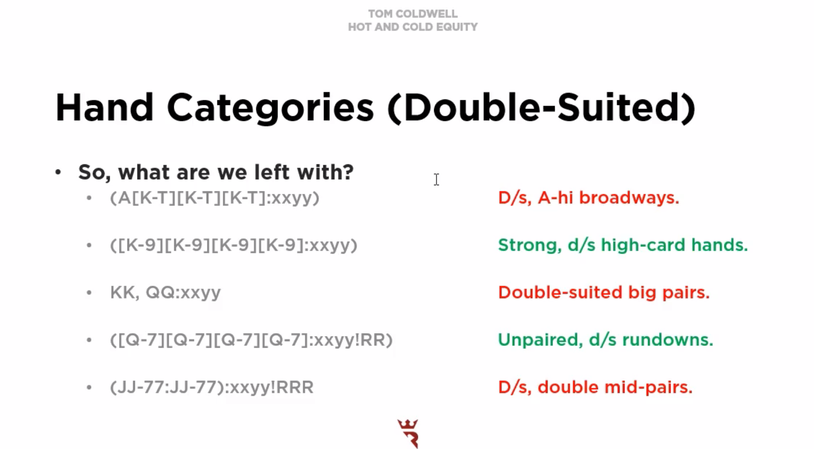

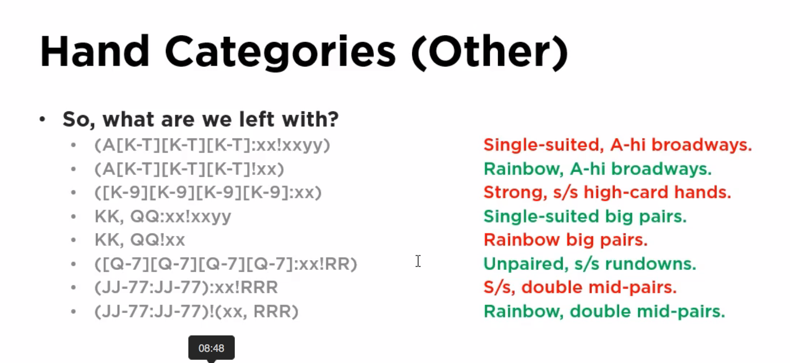

**Step 2: Construct a set of 3-BETTING ranges for the villain**

* Recall that we are constructing a 4-bet range, so we need to have a good sense of the types of hands that would put in a raise pre-flop

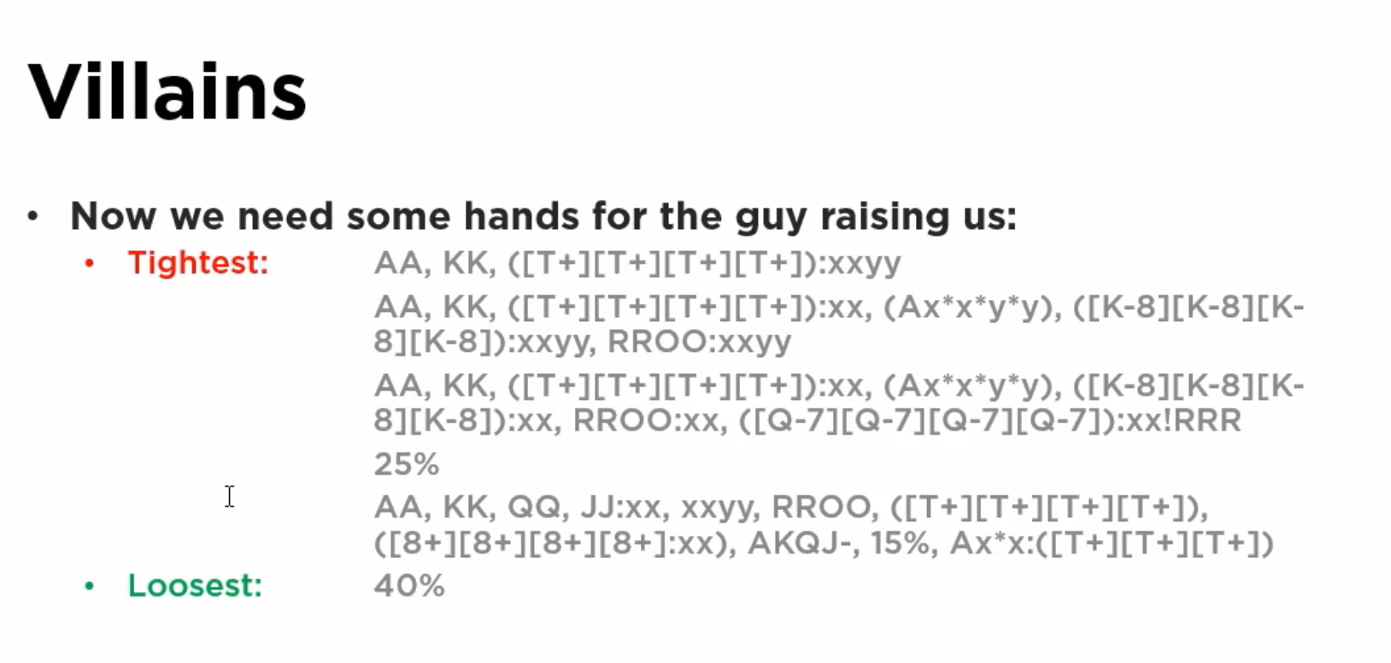

**Step 3: The next steps are to explore the boundaries of the adopted categories and systematically eliminate either [i] hand ranges or [ii] villains.**

* Find the “villain threshold” – are there any villain that have “unbeatable” ranges (i.e., when doing battle all-in pre-flop)
  + Eliminate those villains from the analysis
    - 10% villain is in this category
    - Can only profitably bet AAxx against him
* Find the “hand threshold” – are there any hand categories that are unprofitable even against the loosest villain
  + Eliminate those hand categories from the analysis
    - Single-suited rundowns are inferior against 40% villain

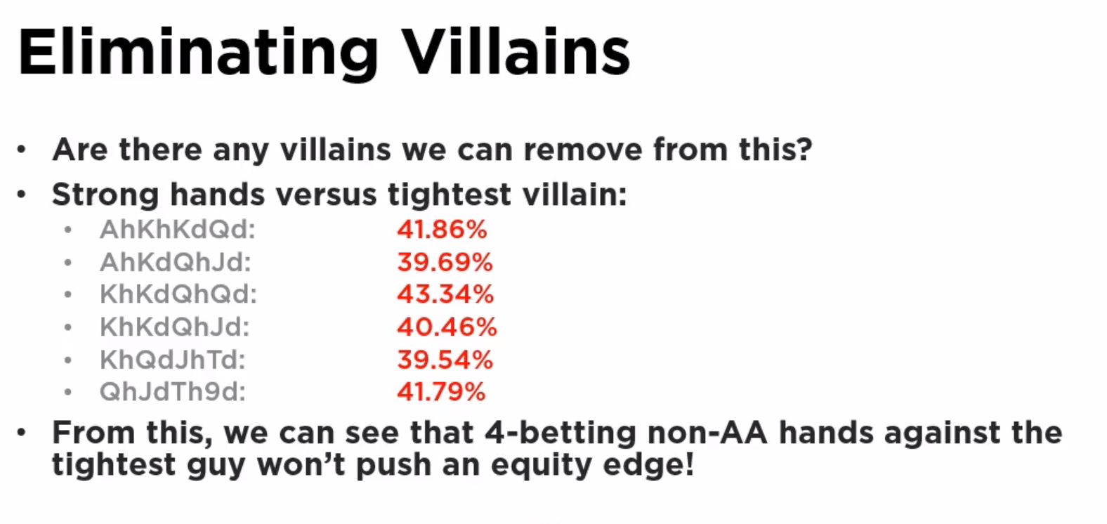

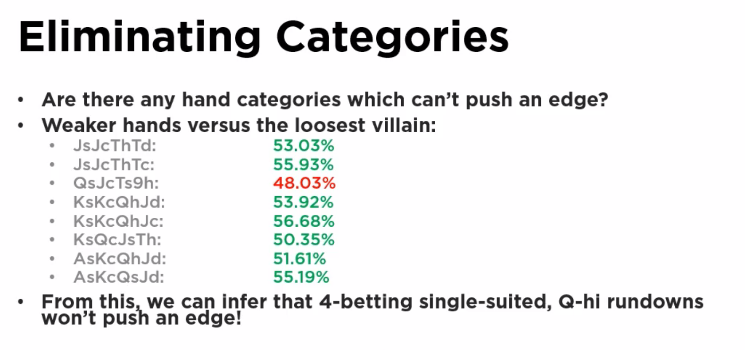

**Step 4: With the remaining categories and villains, test to see what remain as viable 4-bet categories.**

* Examine those categories that fall below a 50% equity. Look both at the top of the range within a hand category (If the top is bad, all are bad) Look at the bottom of the range within a hand category. If the bottom is bad, this will result in a “marginal” hand classification

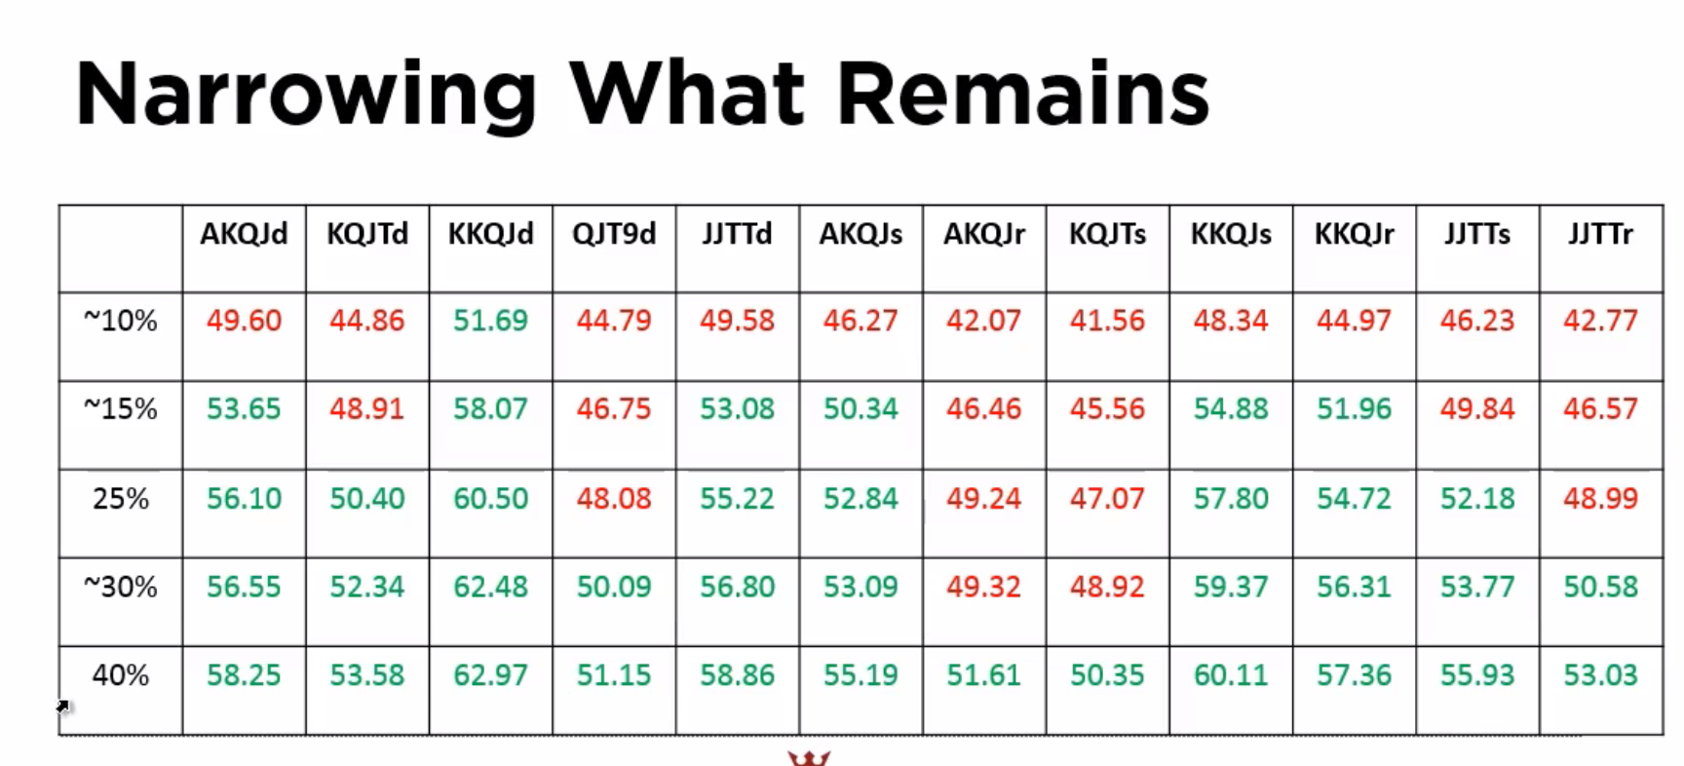

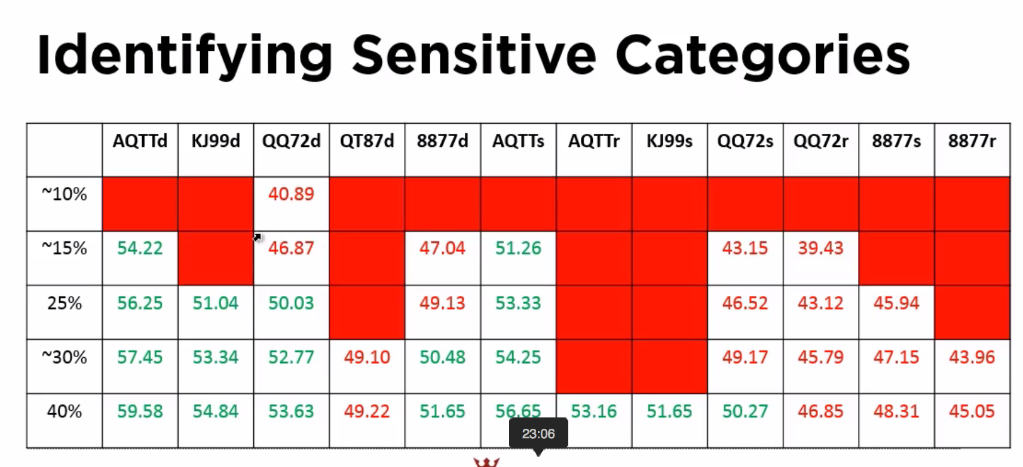

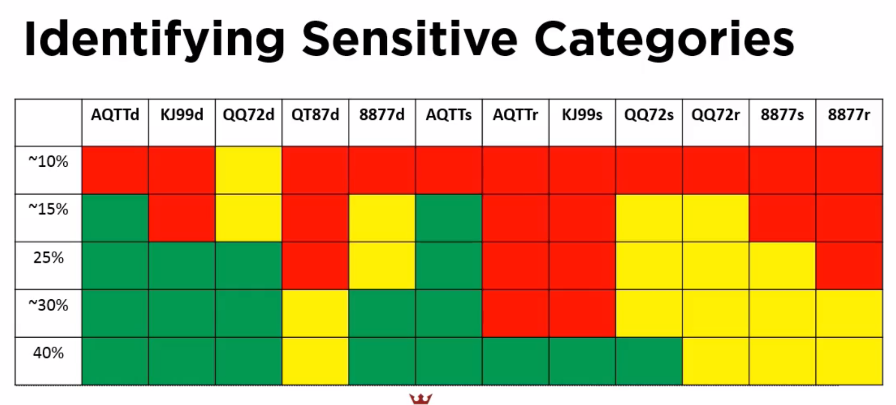

**Step 5: Review the findings**

* Only AAxx (KKxx) hands can do combat against the tightest (10%) 3-betting range
* Pairs have more equity than run-down hands (even some hands considered to be very strong – e.g., double-suited rundowns).
* Against a 15% range, any Broadway hands allow you to push an edge
* Rundowns are not that good (when below King-high)
  + … when pushing pre-flop edges
* Strength of a pair is of greater value (and high cards and blockers) is better than one that “looks pretty” (i.e., a double-suited rundown)

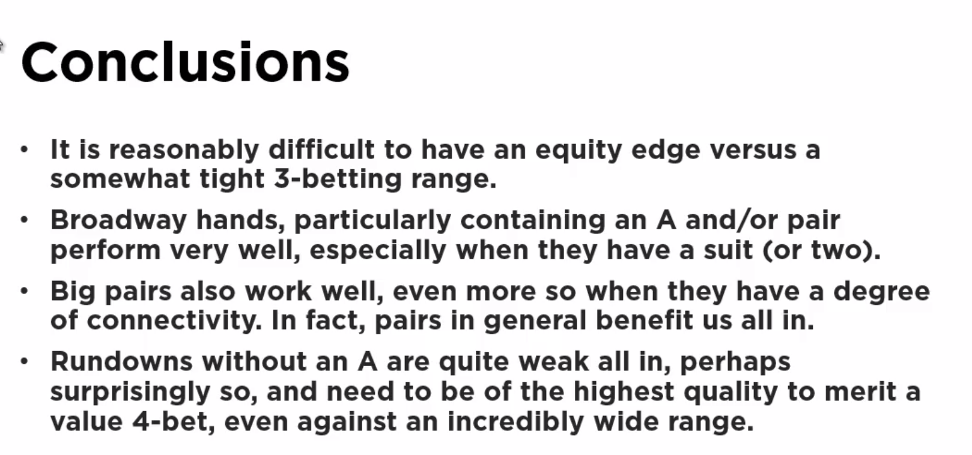

**VIDEO: PLO > Low Stakes > More Hot and Cold Equity**

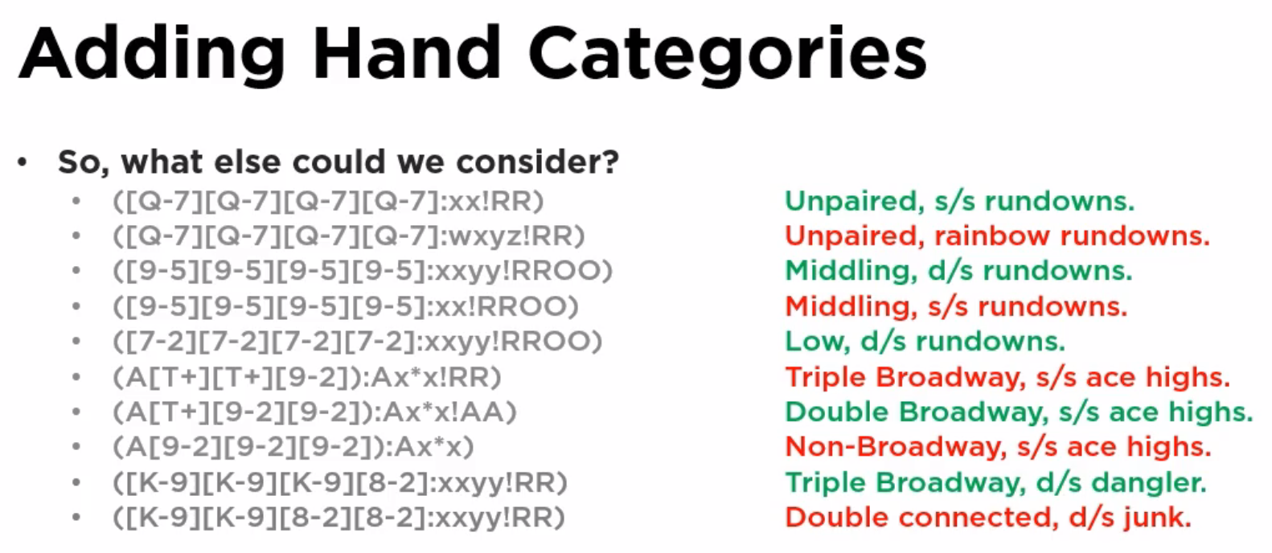

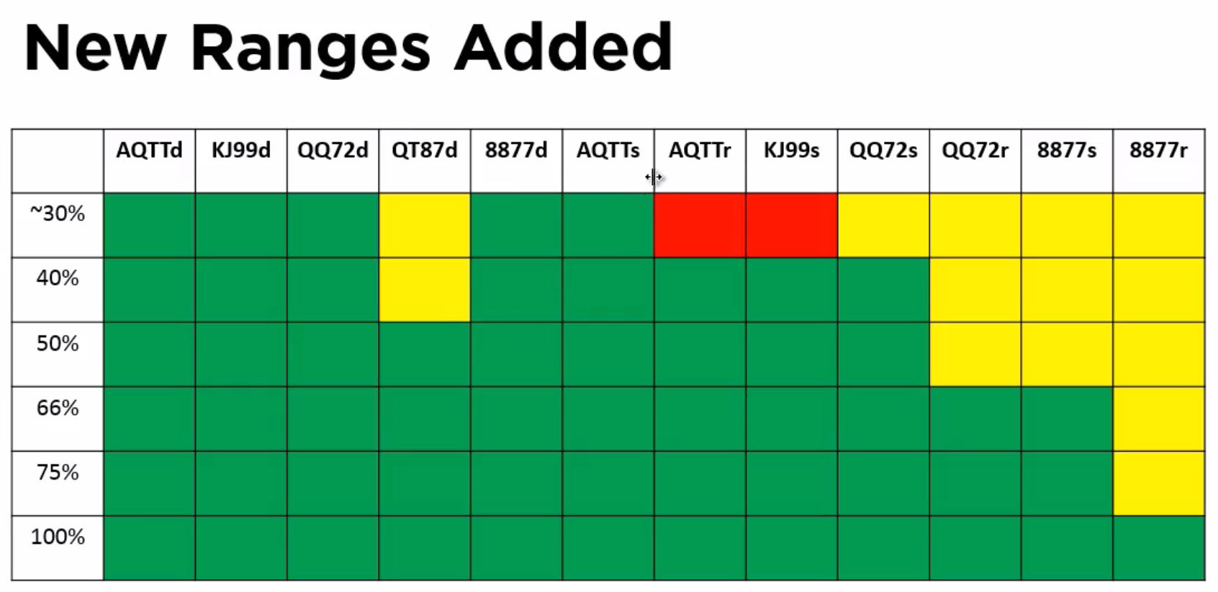

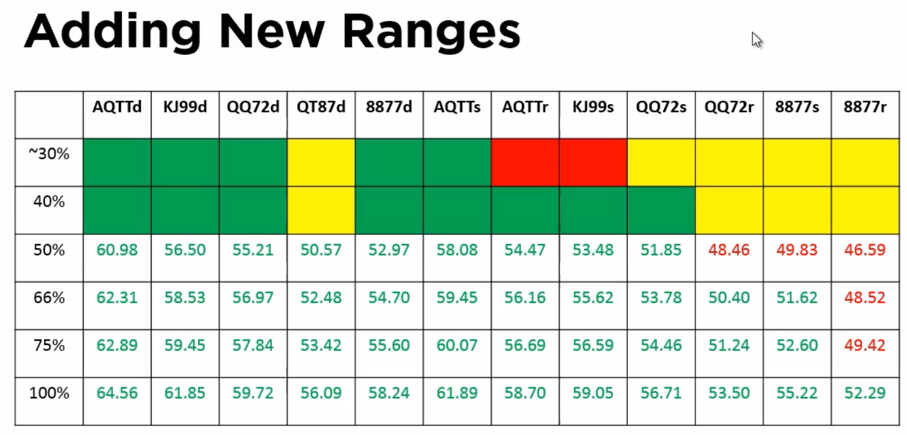

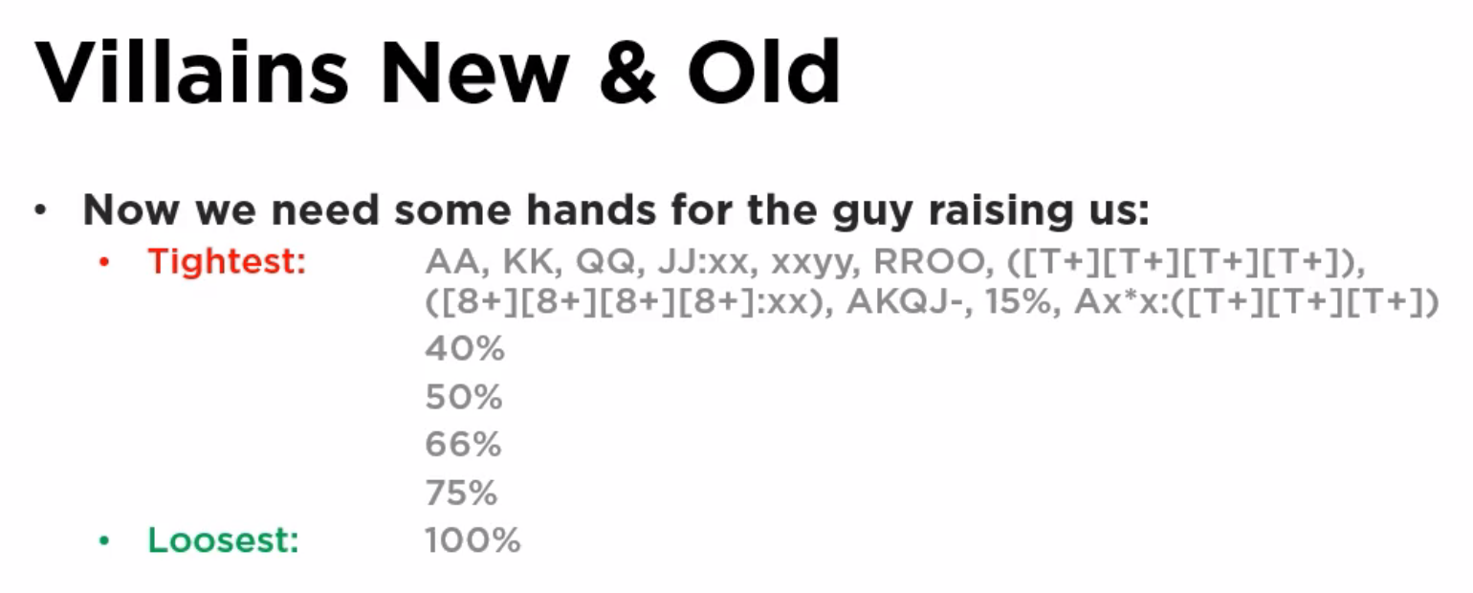

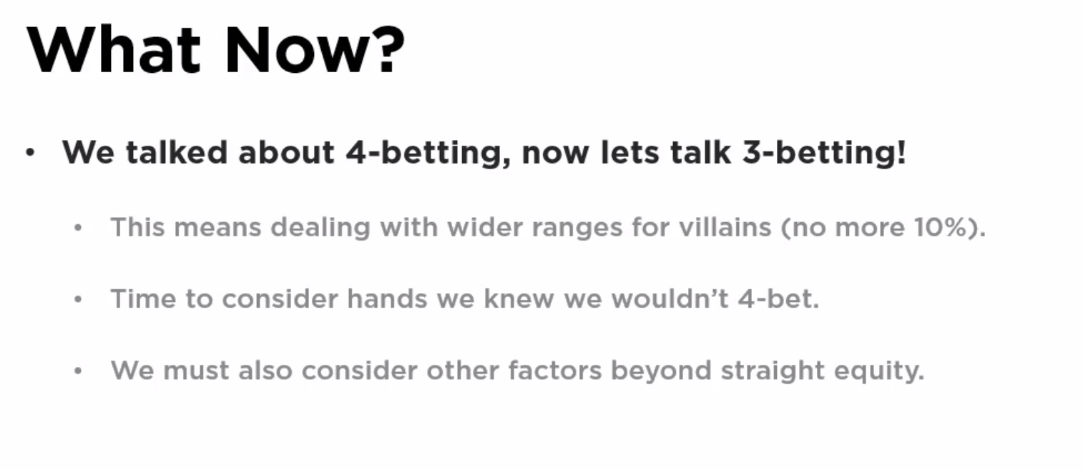

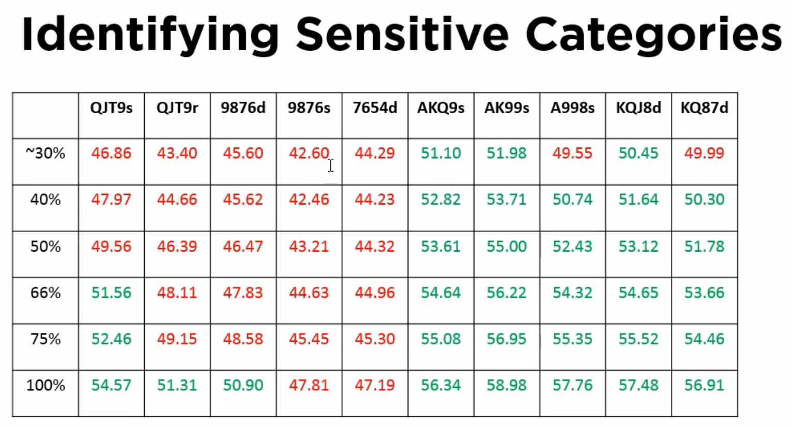



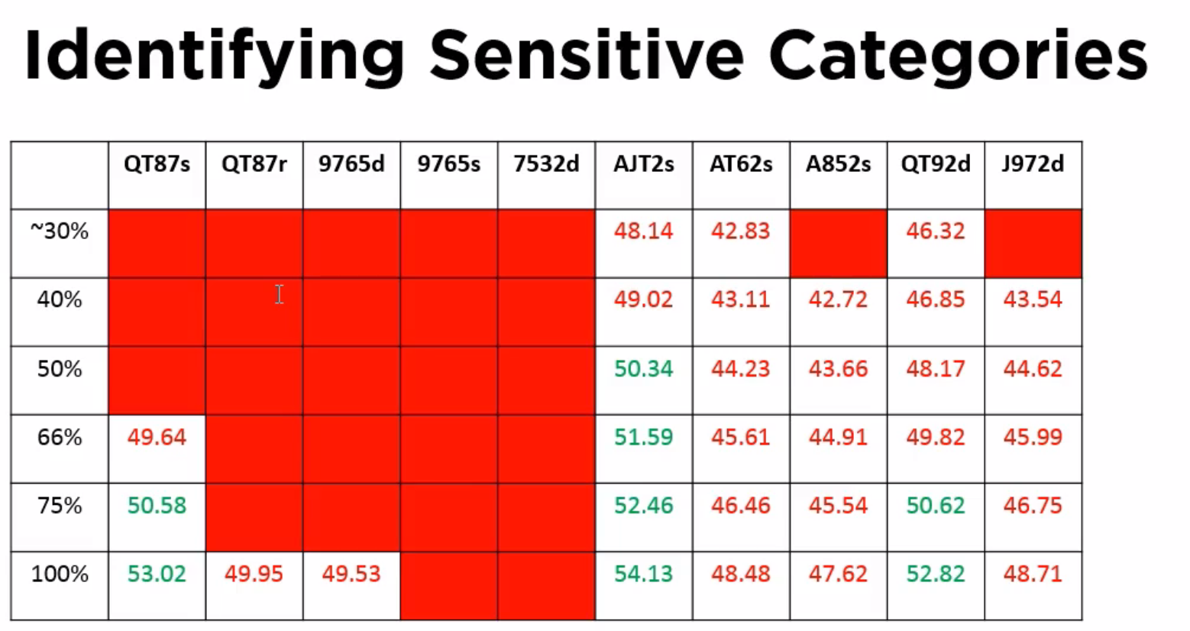

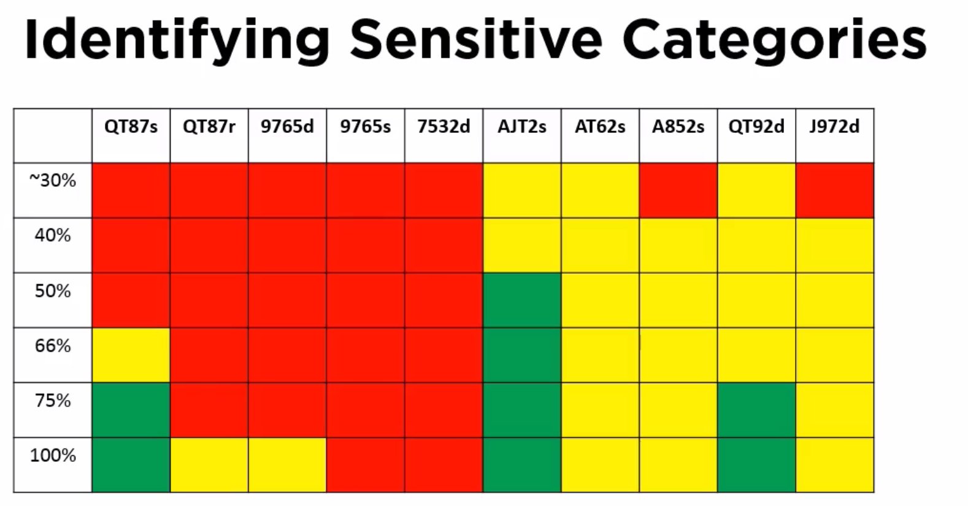

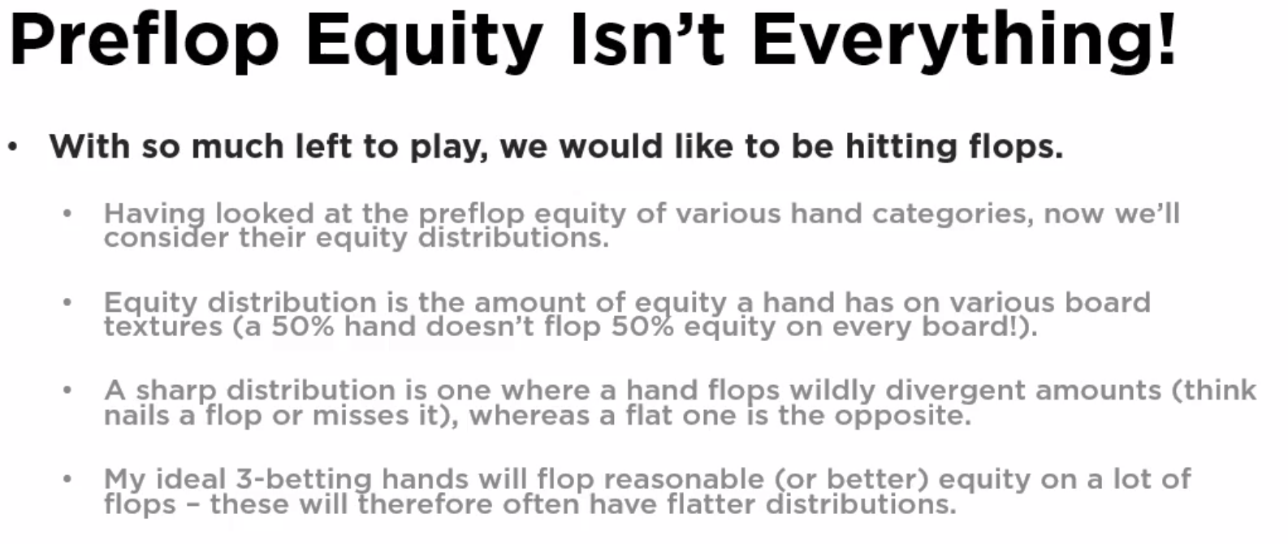

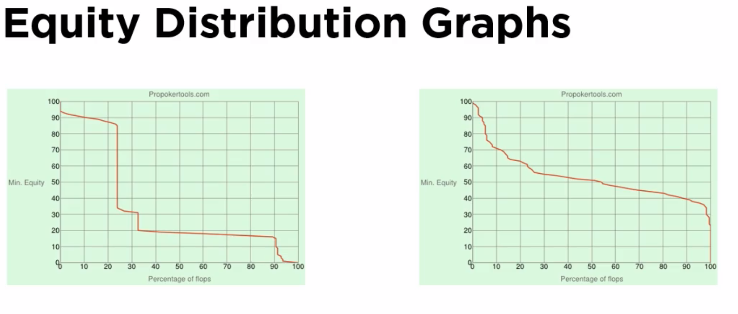

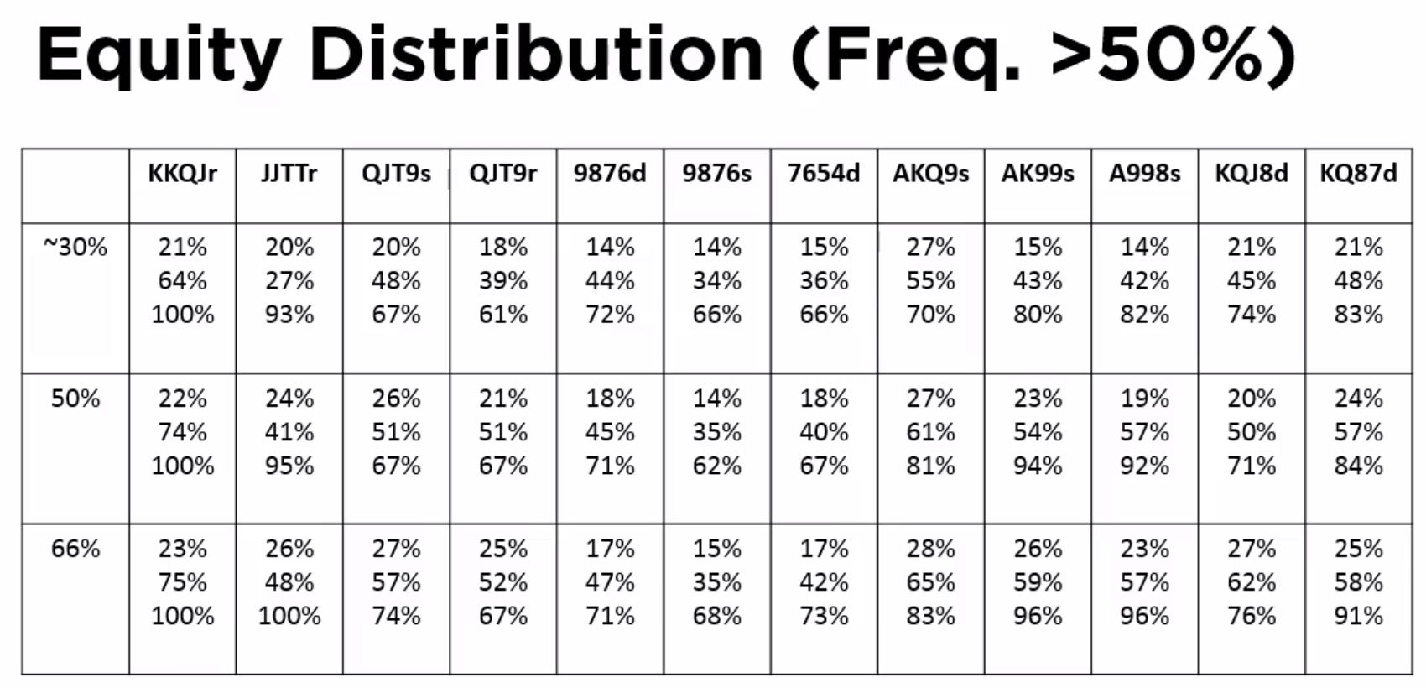

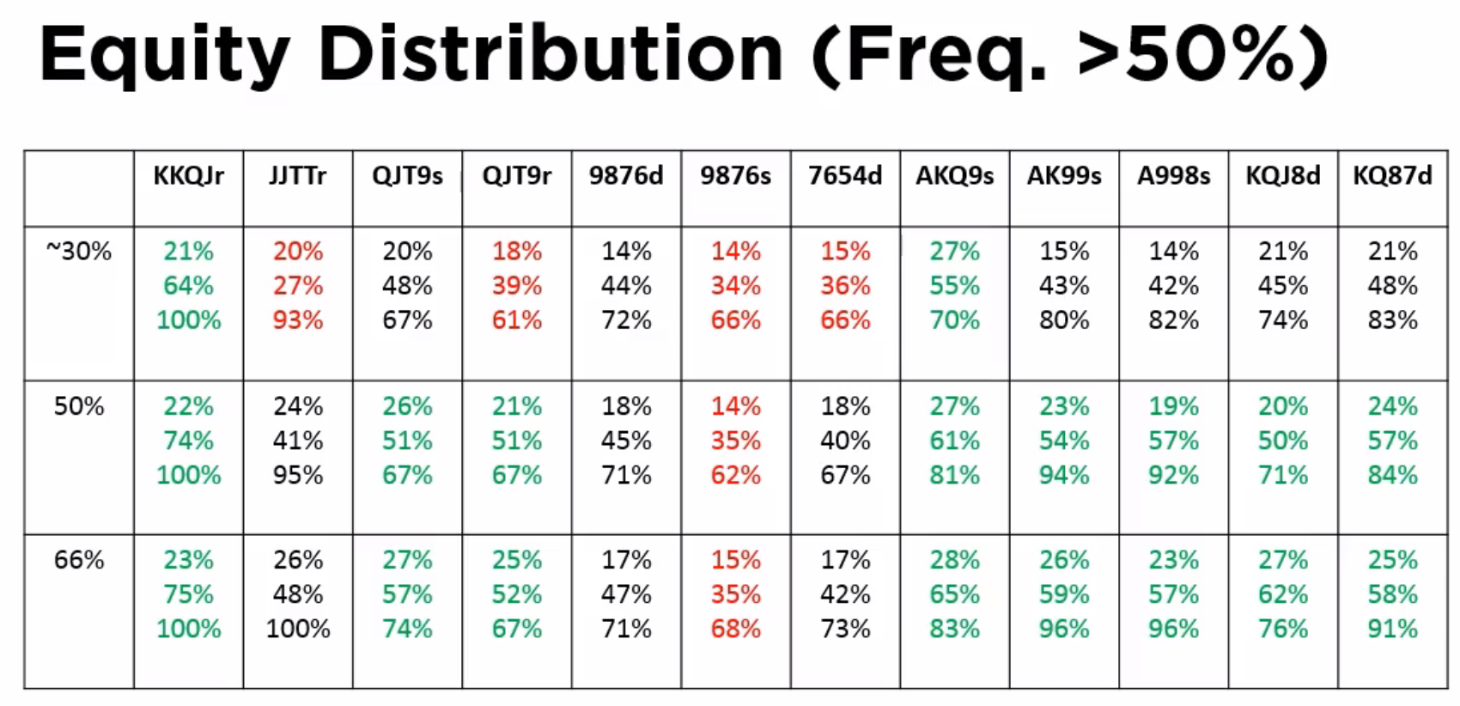

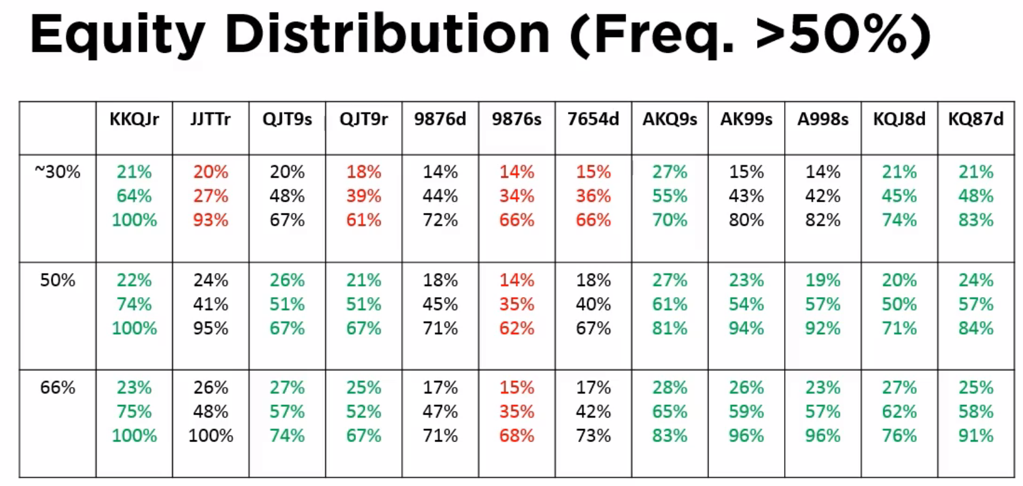

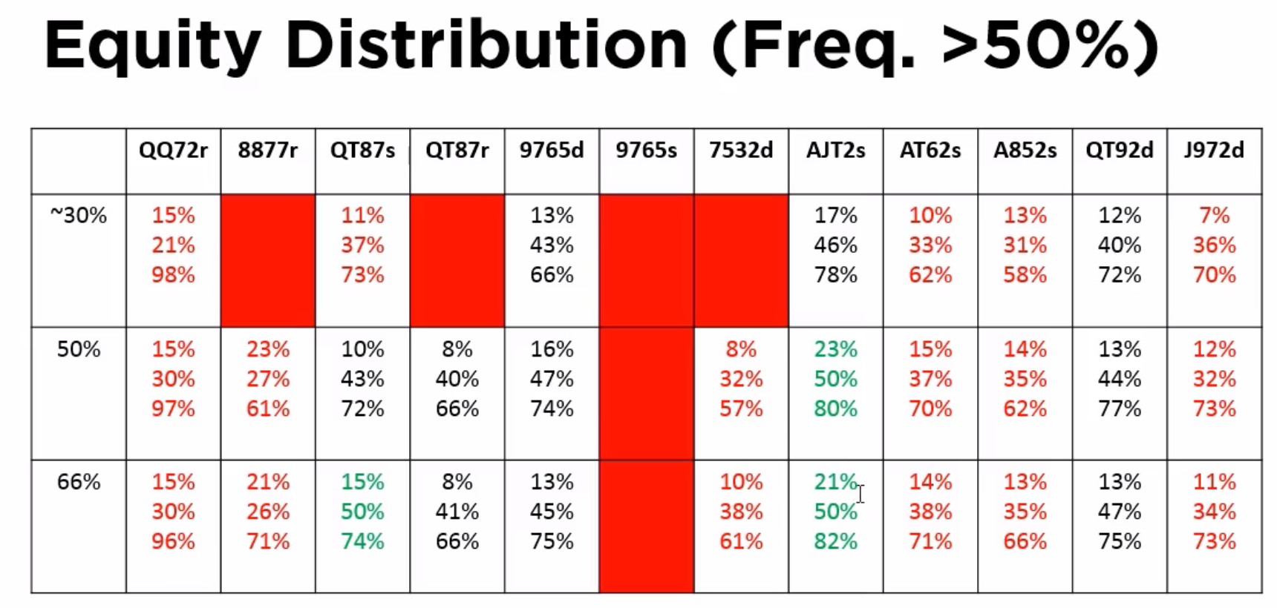

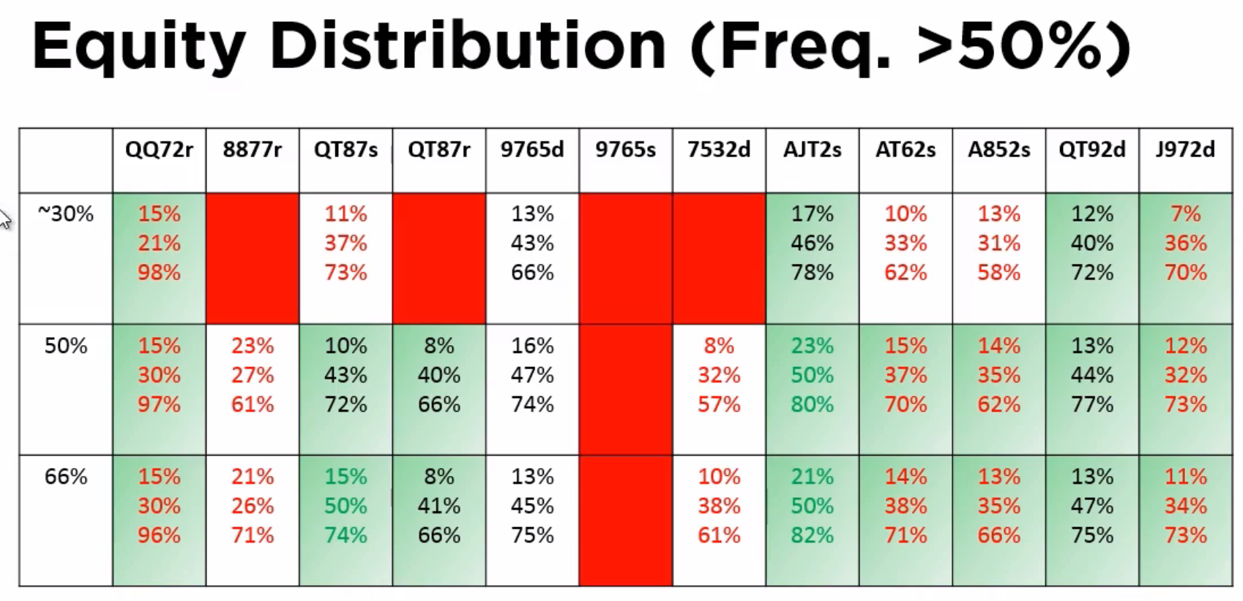

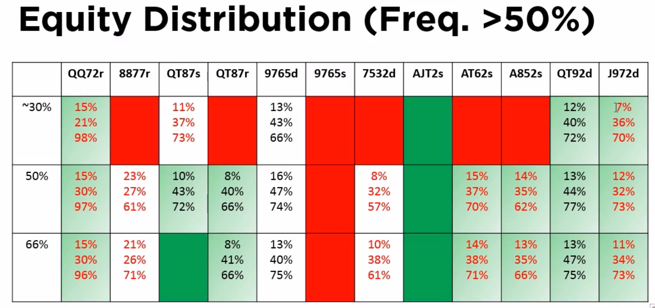

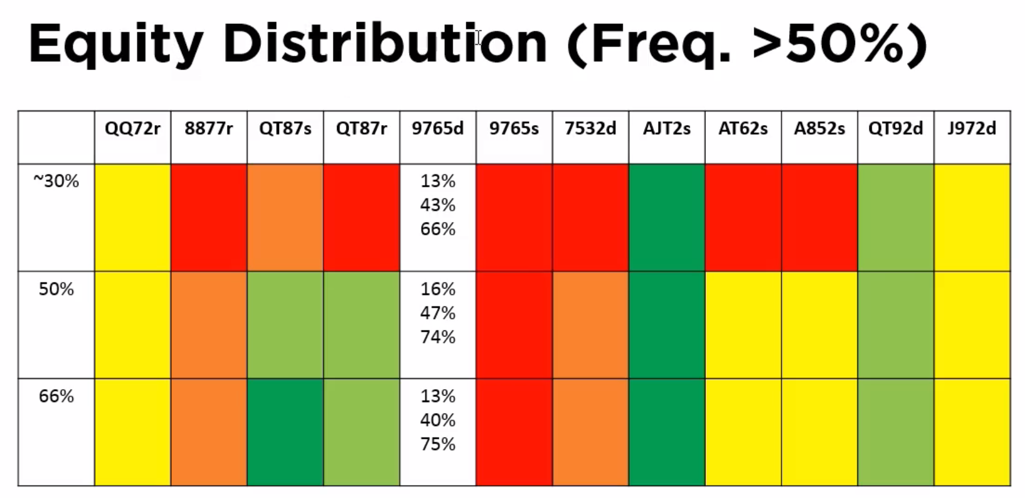

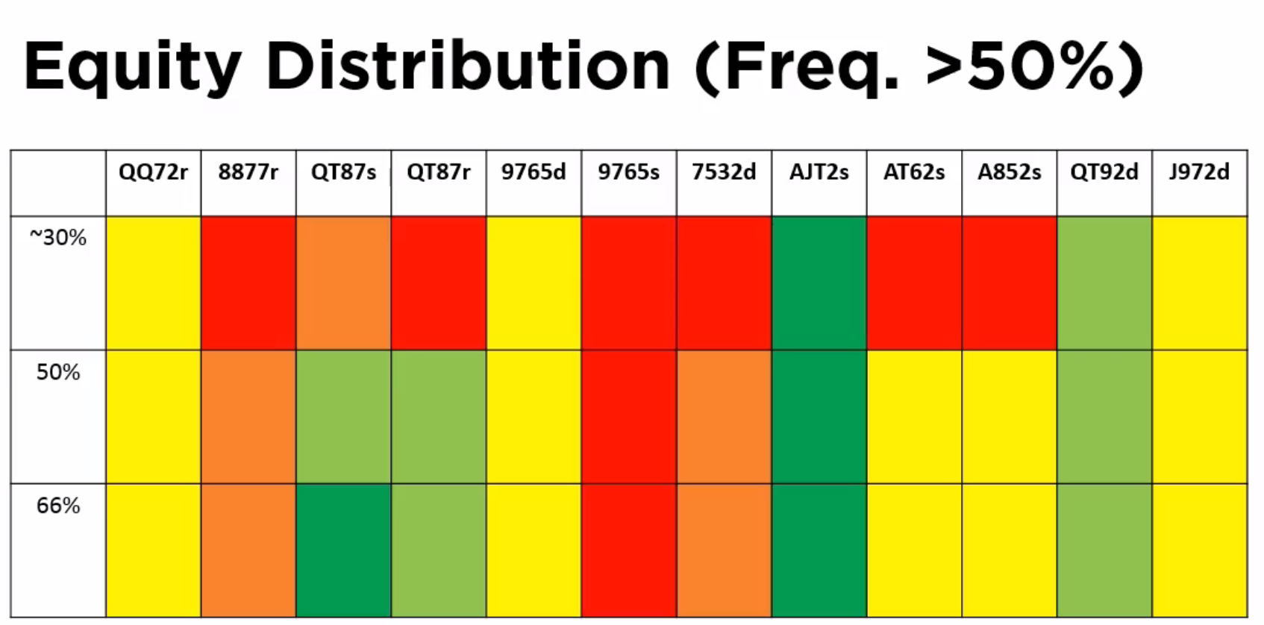

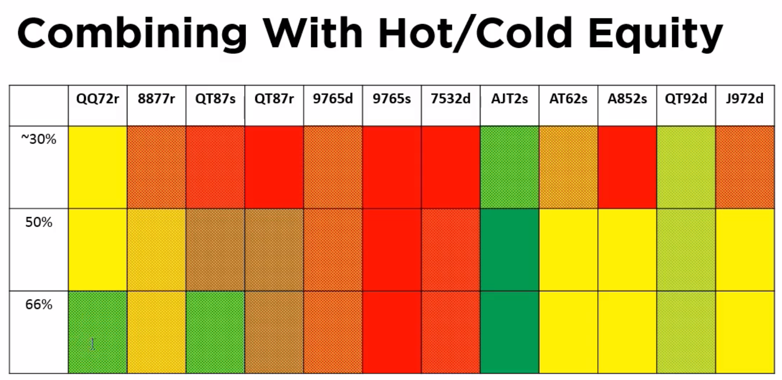

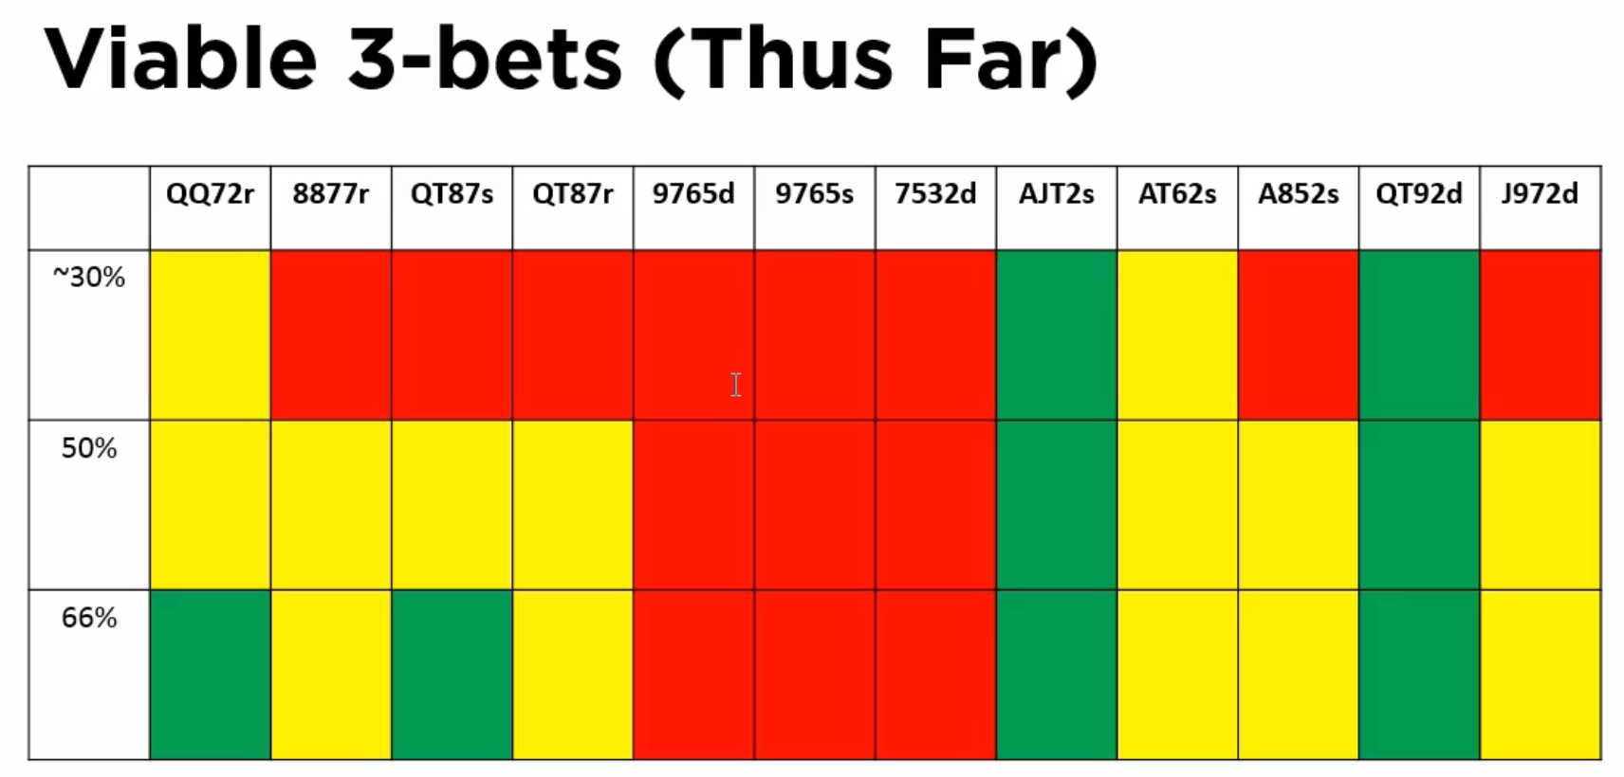

This is a test.

What sort of hands should be 3-bet. Harder than 4-betting

* Have to deal with wider ranges
* Need to consider things other than pre-flop equity
  + Post flop
  + Isolation considerations
  + Balance
  + Board coverage [less relevant for lower stakes]
  + Deception [less relevant for lower stakes]
* Villain ranges
  + Much wider, using coarse % ranges
  + Rainbow big pairs are still weak as are rainbow middle double-pairs
* Add new hand categories to test
  + 10 new categories
* Remove those hand categories that can’t push an edge
  + Being big and being paired is better than being connected
    - Triple broadway single-suited aces
    - Some high-card rundowns with a dangle
  + Lower rundowns do terribly all-in pre-flop
* Also important, is flopping equity (rather than all-in pre-flop equity)
  + Big cards have decent equity distributions on the flop
  + Double-suited hands doing well
  + Rundowns also doing well
* Looking at top and bottom of hand ranges
  + Single-suited uited aces and suited rundowns appear ok at both top and bottom of the range
  + Rainbow big pairs diverge, as are double-suited junk
* Fold-back in hot-and-cold equity
  + Also need to consider isolation (b/c some hands do well HU and poorly multi-way)
* What comes ou
  + Triple broady way single-suited
  + Double suited broadways with a dangler
  + Popular 3-bet hands doing badly
    - Double-suited middle-range rundowns
    - Not pushing an edge, but might be useful for Isolation and deception (board coverage)
* Begin to think about the reasons why were three betting, and why were selecting certain hands to 3-bet
* Have to convolve this information with reads/game flow/etc.

Follow-up Video

**VIDEO: PLO > Low Stakes > Multi-Way Equity**

Assumptions: BTN vs. CO

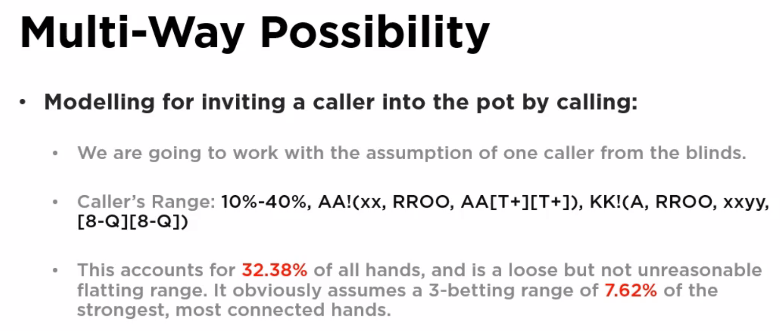

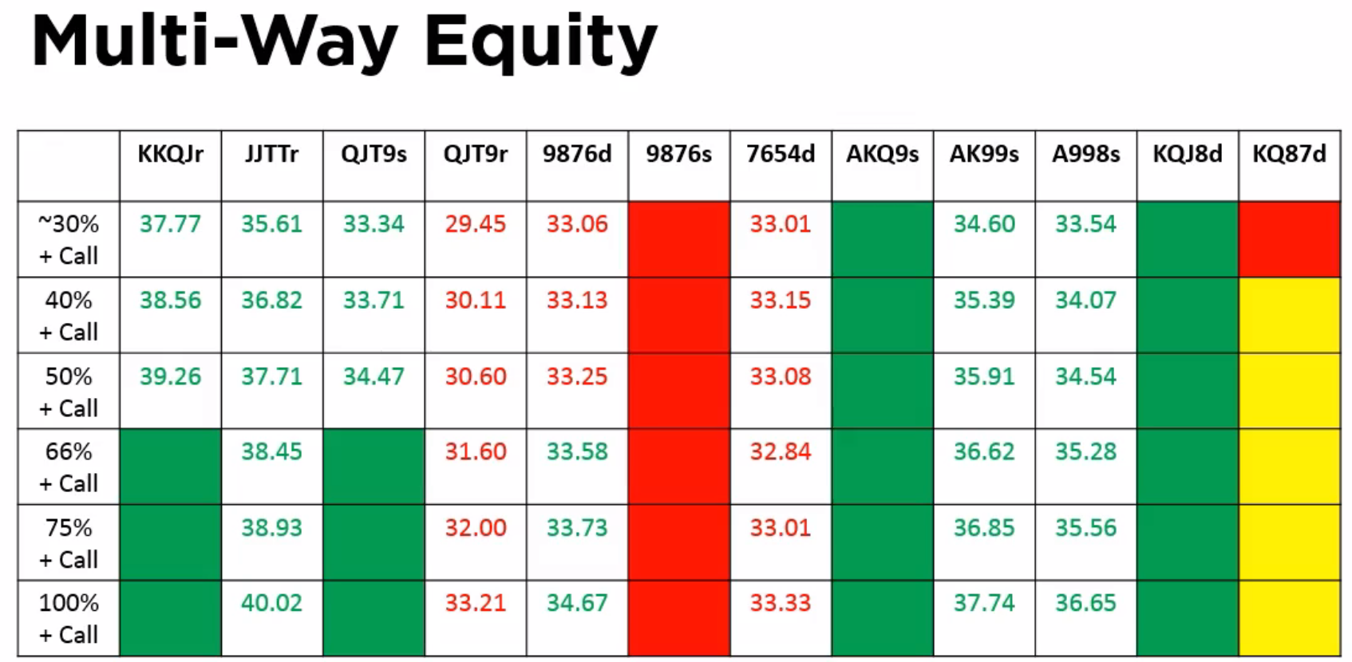

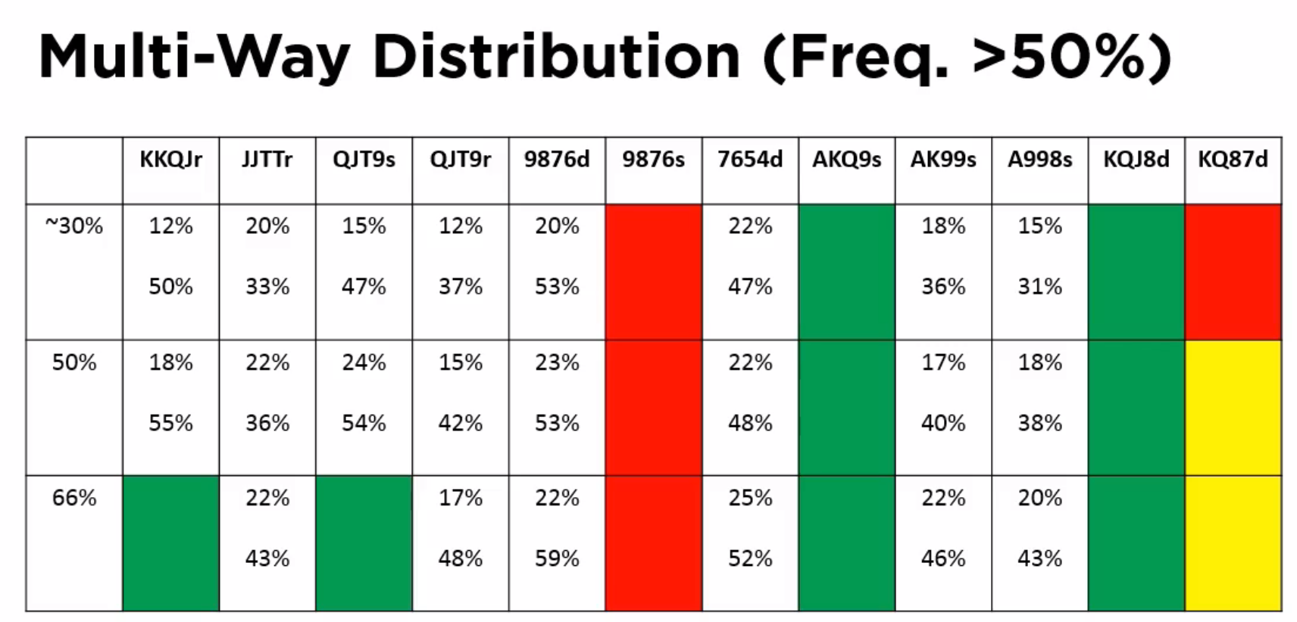

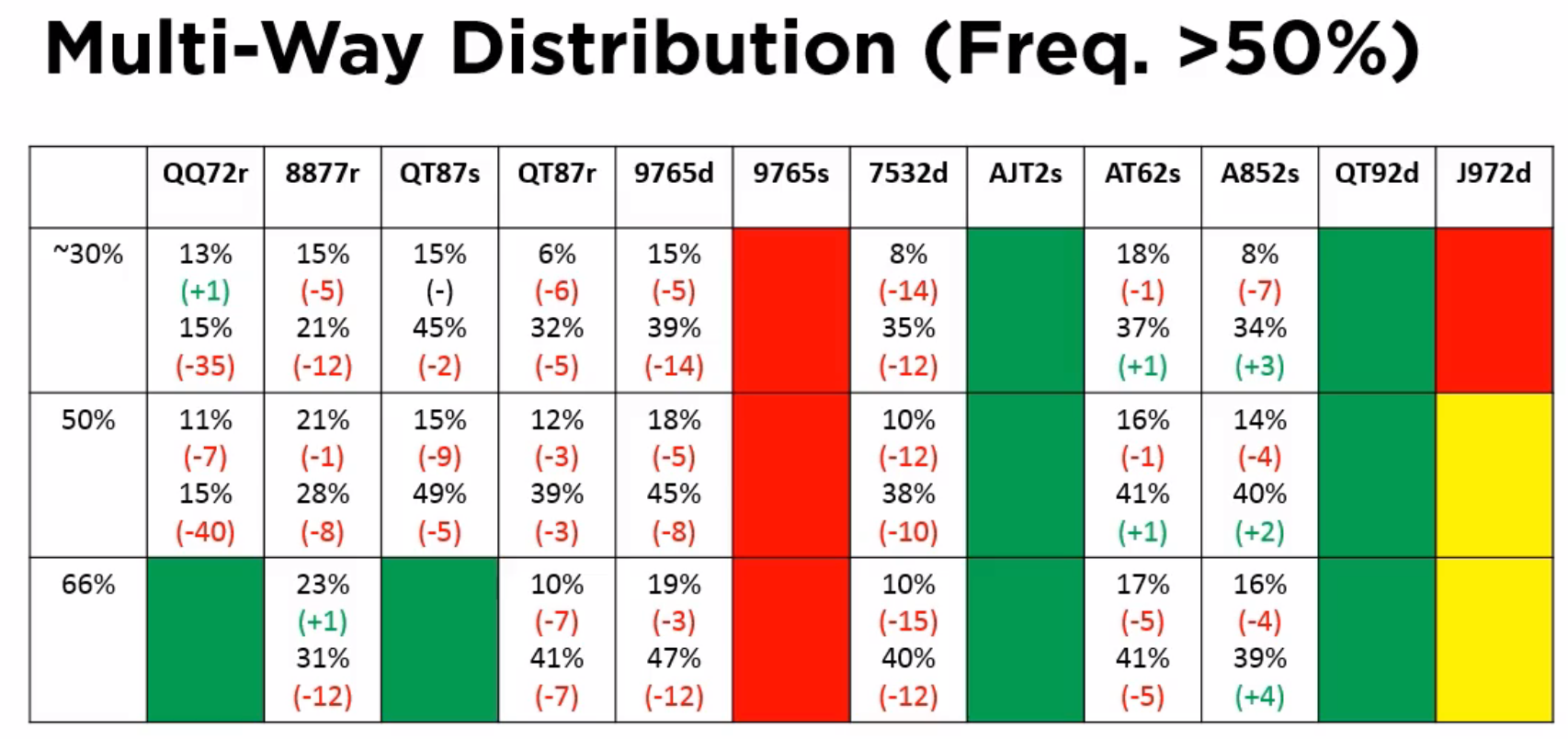

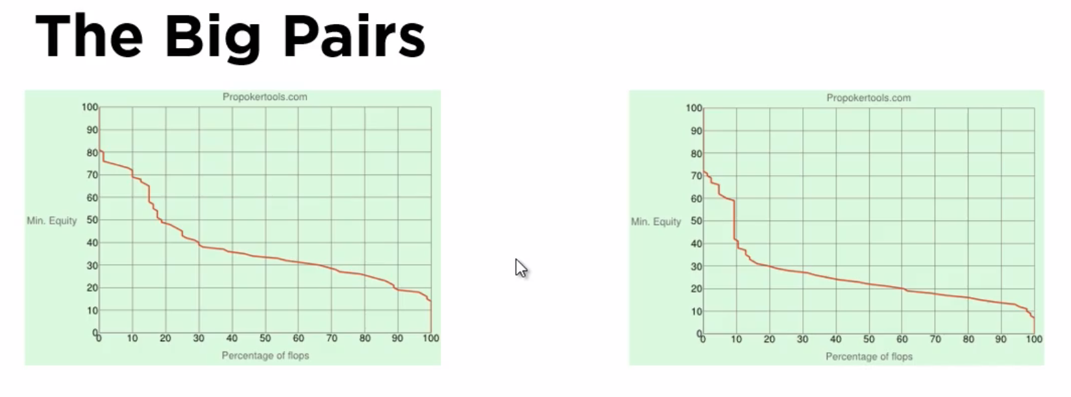

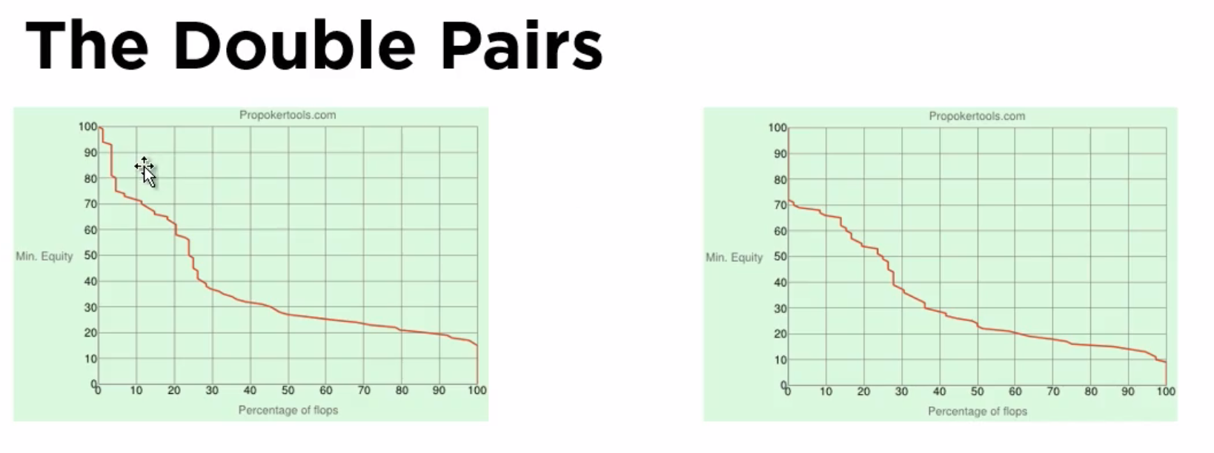

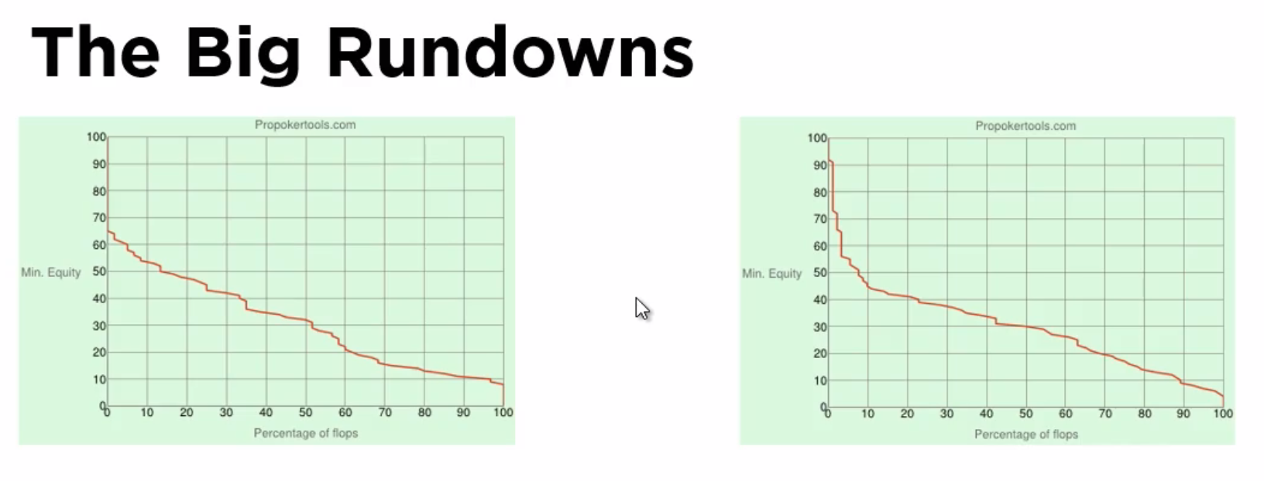

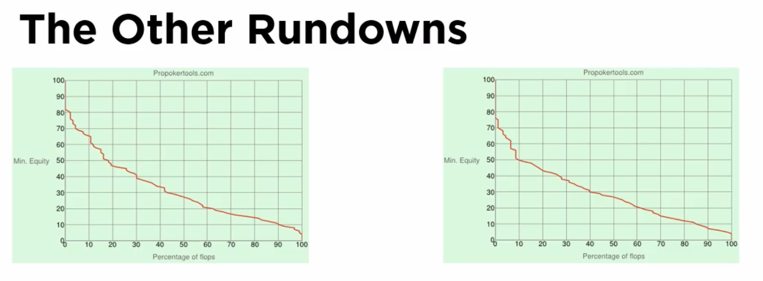

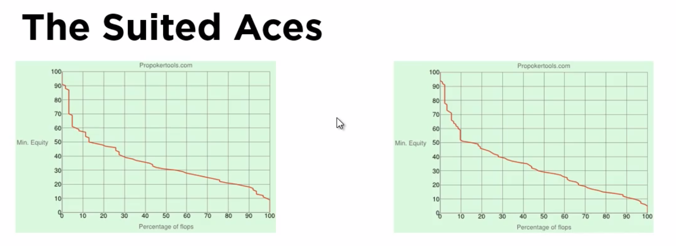

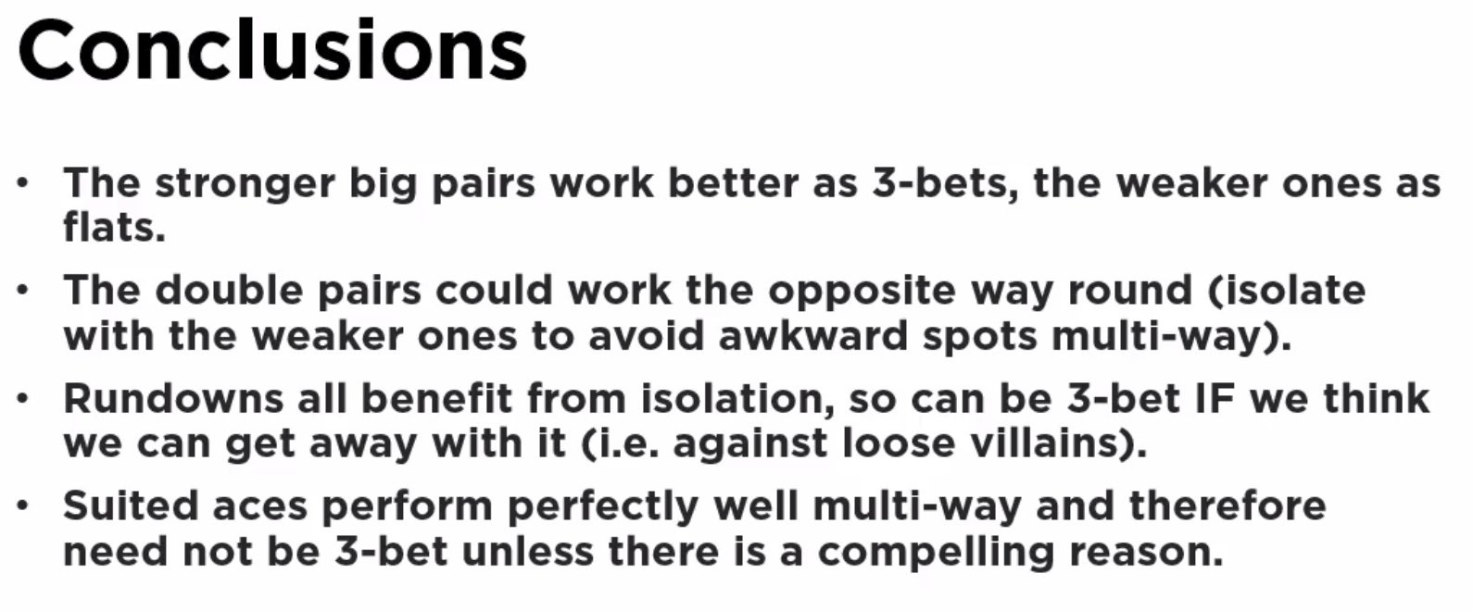

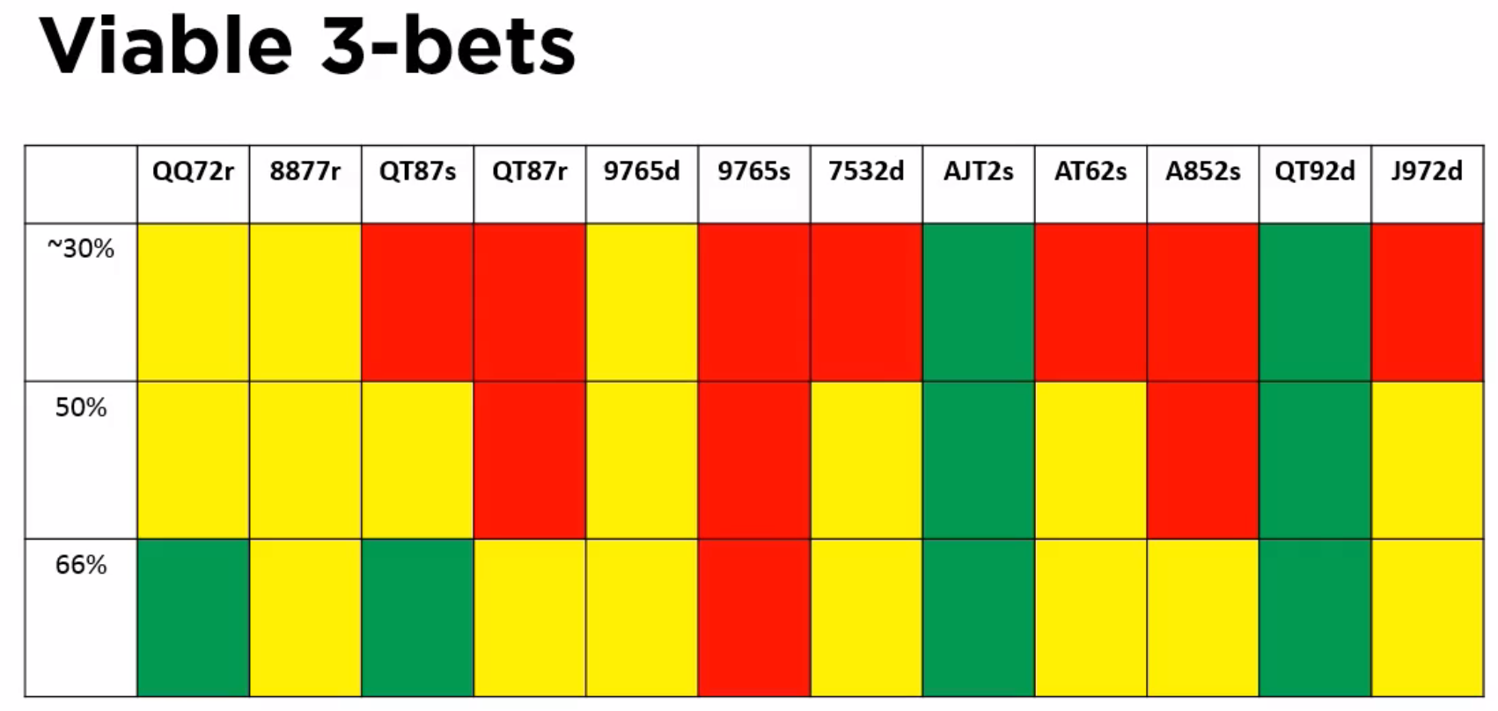

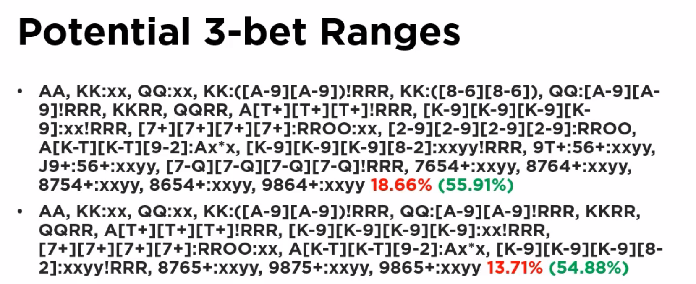

@9min in (multi-way dist (Freq > 50%)

above 50%, above 33%

* mainly want above 50%, rather not have many in 30% -- 50% range
* therefore, hands with a large gap in the two number wont perform well in multiway pots (b/c of sharp fall off in the equity distribution)
* Big pair category showing evidence of large differences between the top and bottom of that particular hand category range
* The rundowns don’t see as much differences across the intra-category range
* Big pair equity dist graph: L=KKQJ vs. 30% range, R=QQ72 vs. 30%
  + QQxx hand shows that it generally either hits a set or nothing
    - But this means they’ll be easy to play
    - Suggests should not be 3-bet
  + KKQJ has a more robust distribution
    - Should be 3-bet b/c we want to avoid a multi-way situation which might be tricky
* Double-pair hands L=JJTT vs. 30%, R=8877
  + Bigger pair has a higher intercept
  + Shallower gradient for the smaller pair (b/c more vulnerable)
  + Should 3-bet smaller/weaker double-pairs ???
    - Don’t push equity edge HU, should get enough c-bets through to make it ok
  + Should play bigger double-pairs multiway ???
    - They should work ok in multiway pots
  + On boards that we miss, both will perform well when we miss
  + But JJTT outperforms
* Big Rundowns
  + L/R = Q-high rundowns
  + Very similar profiles;
    - Both have some equity (a little but not a lot), so you’ll be struggling more to play these hands
    - Will be less sure of the hand when you lop a bit of “something”
  + Given the opportunity we’d like to 3-bet
* Lower rundowns
  + Here these include double-suited (the big rundowns only included single-suited and rainbows)
  + Benefit from isolation
* Suited Aces
  + Peaked, but then slow decline in equity (which can be troubling)
  + … but Tom isn’t much concerned about the profile b/c the flush draw is generally the nut-flush, so it is easy to play
  + Works well multiway; not benefiting from multiway (on average)
    - Makes sense to 3-bet the better hands to push an edge
* Conclusions
  + Diagram excludes the super-premium 4-bettable hands
  + Double-suited rundowns could be marked green (9765d column)
  + Double-pairs (3-bet weaker and
* Ranges
  + Top vs. guy opening vs. 60%
  + Bottom vs. guy opening the custom 32.8% range
  + TAKE SECOND IMAGE B/C HE CORRECTED ON THE FLY